LAB ASSIGNMENT – 8.1
NAME : B.SHYAM
HALL.NO : 2403A52396
BATCH.NO : AI 14
PLATFORM USED : GOOGLE COLLAB AND perplexity.ai

PROMPT 01 :
write a python code that generate at least 3 assert test cases for is_strong_password(password) and implement the validator function.
Requirements: Password must have at least 8 characters. Must include uppercase, lowercase, digit, and special character. Must not contain spaces.
Example Assert Test Cases:
assert is_strong_password("Abcd@123") == True
assert is_strong_password("abcd123") == False
assert is_strong_password("ABCD@1234") == True

OUTPUT :
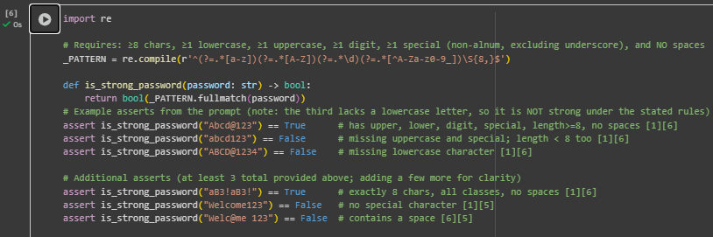

CODE EXPLANATION :
- Pattern logic: use lookaheads to “require” character types: (?=.*[a-z]) lowercase, (?=.*[A-Z]) uppercase, (?=.*\d) digit, (?=.*[^A-Za-z0-9_]) special character (non-alphanumeric excluding underscore).
- Length and spaces: \S{8,} at the end enforces at least 8 characters and forbids any whitespace (spaces, tabs, newlines).
- Full string check: .fullmatch(...) anchors the whole password so partial matches can’t pass.
- Why “ABCD@1234” is False: it has uppercase, digit, special, but no lowercase letter; the rule needs all four categories.
- Test coverage idea: include positive exact-length case (e.g., 8 chars), negatives for missing special/uppercase, and a case with a space to confirm whitespace rejection.

PROMPT 02 :
write a python code that generate at least 3 assert test cases for a classify_number(n) function. Implement using loops. Requirements: Classify numbers as Positive, Negative, or Zero.Handle invalid inputs like strings and None. Include boundary conditions (-1, 0, 1).
Example Assert Test Cases:
assert classify_number(10) == "Positive"
assert classify_number(-5) == "Negative"
assert classify_number(0) == "Zero"

OUTPUT :

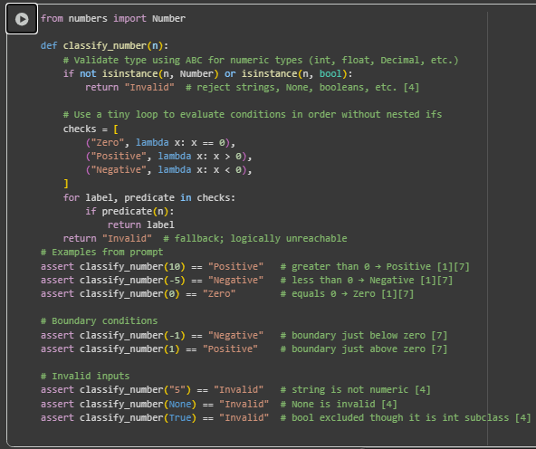
CODE EXPLANATION :
- Type check first: reject non-numeric inputs using isinstance(n, Number) and also exclude booleans (since True/False are subclasses of int) to return "Invalid".
- Use a small loop of labeled checks instead of nested if-elif: iterate over predicates for Zero (x == 0), Positive (x > 0), and Negative (x < 0), and return the matching label.
- Boundary coverage: explicit asserts for -1, 0, and 1 verify correct behavior around zero.
- Invalid input coverage: asserts for "5", None, and True ensure strings, NoneType, and booleans are handled safely.
- Deterministic order: checking Zero first avoids misclassifying 0 as Positive/Negative, then >0 for Positive, and finally <0 for Negative.

PROMPT 03 :

write a python code that generate at least 3 assert test cases for is_anagram(str1, str2) and implement the function.
Requirements:Ignore case, spaces, and punctuation.
Handle edge cases (empty strings, identical words).
Example Assert Test Cases:
assert is_anagram("listen", "silent") == True
assert is_anagram("hello", "world") == False
assert is_anagram("Dormitory", "Dirty Room") == True

OUTPUT :

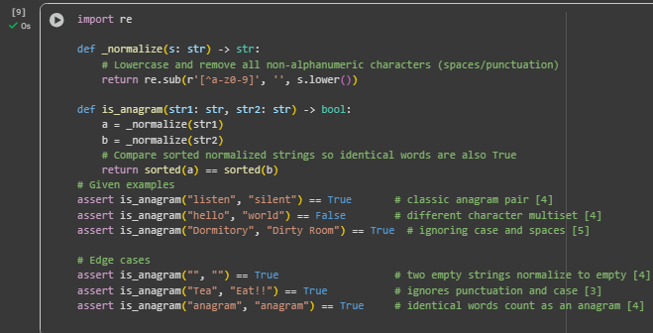

CODE EXPLANATION :
- Normalize both strings: convert to lowercase and remove everything except letters/digits using a regex like re.sub(r'[^a-z0-9]', '', s.lower()), so case, spaces, and punctuation are ignored.
- Compare character multisets: sort the normalized strings and check equality; if the sorted results match, they are anagrams.
- Empty strings: after normalization, two empty strings both sort to an empty list, so they are considered anagrams by definition.
- Identical words: normalization keeps the same characters, so comparing sorted forms returns True for the same word.
- Robustness: using normalization before comparison ensures inputs like "Dormitory" vs "Dirty Room!!" are handled correctly without special casing.

PROMPT 04 :
Write a python code that generate at least 3 assert-based tests for an Inventory class with stock management.
Methods:add_item(name, quantity)remove_item(name, quantity)get_stock(name)
Example Assert Test Cases:
inv = Inventory()
inv.add_item("Pen", 10)
assert inv.get_stock("Pen") == 10
inv.remove_item("Pen", 5)
assert inv.get_stock("Pen") == 5
inv.add_item("Book", 3)
assert inv.get_stock("Book") == 3

OUTPUT :

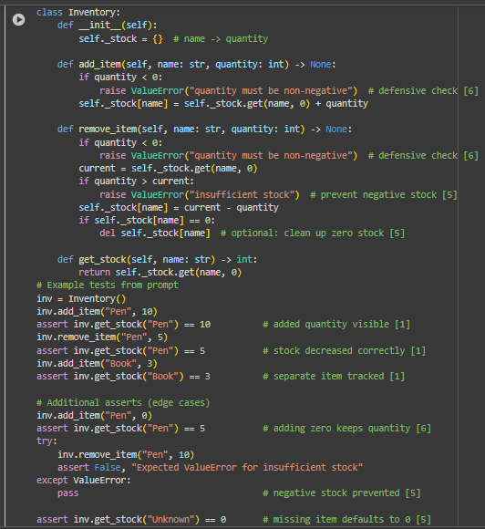

CODE EXPLANATION :
- Data structure: a dictionary maps item names to quantities, so add_item increments the count, remove_item decrements it, and get_stock returns 0 for unknown items to keep lookups simple.
- Input validation: add_item and remove_item reject negative quantities; remove_item also raises an error if the requested removal exceeds current stock, preventing negative inventory.
- Zero cleanup: after removing, if an item’s quantity reaches 0, it’s deleted from the dictionary to keep the inventory compact and accurate.
- Test coverage: asserts check normal flows (add/get, remove/get), boundary behavior (adding zero, querying unknown items), and error handling (insufficient stock raises an exception).
- Why it’s reliable: using a single source of truth (the dictionary) and small, focused methods makes reasoning, debugging, and extending the class straightforward for typical stock

PROMPT 05 :

Write a python code that generate at least 3 assert test cases for validate_and_format_date(date_str) to check and convert dates.Requirements:Validate "MM/DD/YYYY" format.Handle invalid dates.Convert valid dates to "YYYY-MM-DD".
Example Assert Test Cases:
assert validate_and_format_date("10/15/2023") == "2023-10-15"
assert validate_and_format_date("02/30/2023") == "Invalid Date"
assert validate_and_format_date("01/01/2024") == "2024-01-01"

OUTPUT :

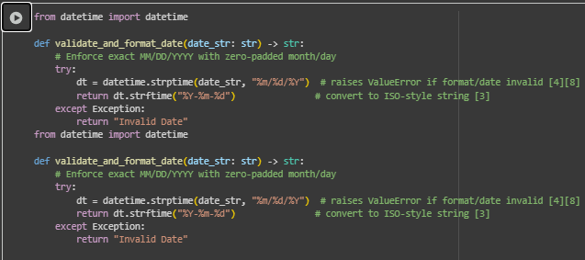

CODE EXPLANATION :
- Parsing vs formatting: strptime parses a string date into a datetime object using a format like "%m/%d/%Y", while strftime formats that datetime back to a string such as "YYYY-MM-DD".
- Strict validation: datetime.strptime enforces both the exact pattern and calendar correctness, so inputs like "02/30/2023" or "13/01/2023" raise errors and can be reported as "Invalid Date".
- Zero-padding required: the "%m/%d/%Y" pattern expects zero-padded month/day (e.g., "02/05/2023"), so variants like "2/5/2023" should be treated as invalid if strict formatting is desired.
- Conversion step: on successful parse, dt.strftime("%Y-%m-%d") reliably converts the valid date to ISO-like "YYYY-MM-DD".
- Edge behavior: the try/except wrapper cleanly returns "Invalid Date" for any mismatches or impossible dates, keeping the function simple and safe.

